**Task 1**

* **Connection pooling and Prepared statement:**

As is required in the project, we need to use connecting pooling and prepared statement in the parts related to the search function.

Edit two xml files first to implement connection pooling.

The first file is context.xml, located in **/WebContent/META-INF.**

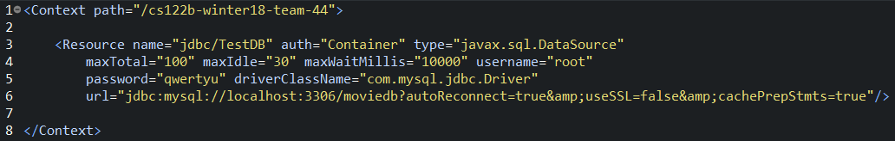

Here max-idle and max-total are enough because we don’t need too many parallel requests.

We use TestDB to send normal read request to the server.

The second file is web.xml, located in **/WebContent/WEB-INF from line 12 to 26.**

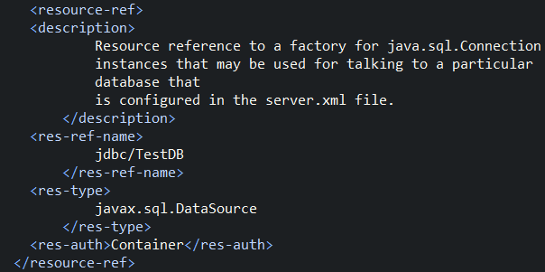

In java files, firstly we modified **Search.java** for website search, located in **/src/**

import the jar file: **from line 26 to 28**

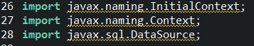

Get connection using connection pooling: **from line 97 to 100**

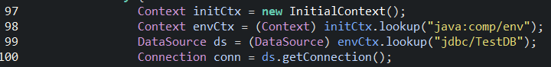

use the connection “conn” to implement the prepared statement: **from line 117 to 121 and 141 to 146;**





Secondly, we modified showmovie.java for android search, also located in **/src/**

Importing the jar file is the same as Search.java. For connection pooling: **from line 58 to 61**

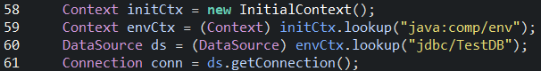

For prepared statement: **from line 84 to 87**



**Task 2**

* **Address of AWS and Google instances**

1. Main instance that deployed our application originally on AWS:

Public IP: 13.57.29.131

1. Master instance:

Public IP: 54.67.27.245

1. Slave instance:

Public IP:54.241.244.209

1. Google instance:

Public IP: 35.229.78.83

* **Have you verified that they are accessible? Does Fablix site get opened both on Google’s 80 port and AWS’ 8080 port?**

Yes, they are all accessible and both two ports are open. I have already deployed our application to all the servers for testing. You can access any of them by clicking the following links:

On AWS main instance: <http://13.57.29.131:8080/cs122b-winter18-team-44/>

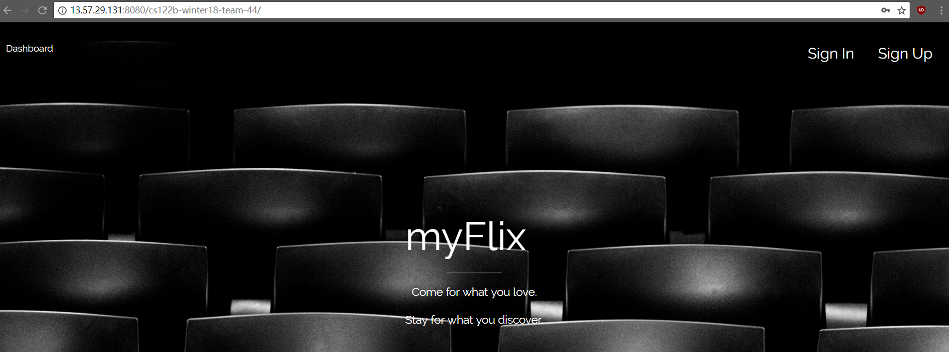

On master instance: <http://54.67.27.245:8080/cs122b-winter18-team-44/>

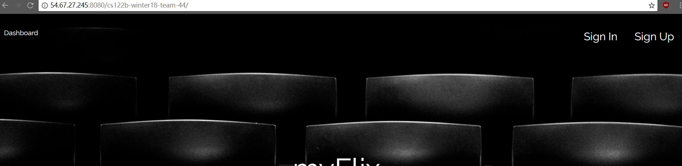

On slave instance: <http://54.241.244.209:8080/cs122b-winter18-team-44/>

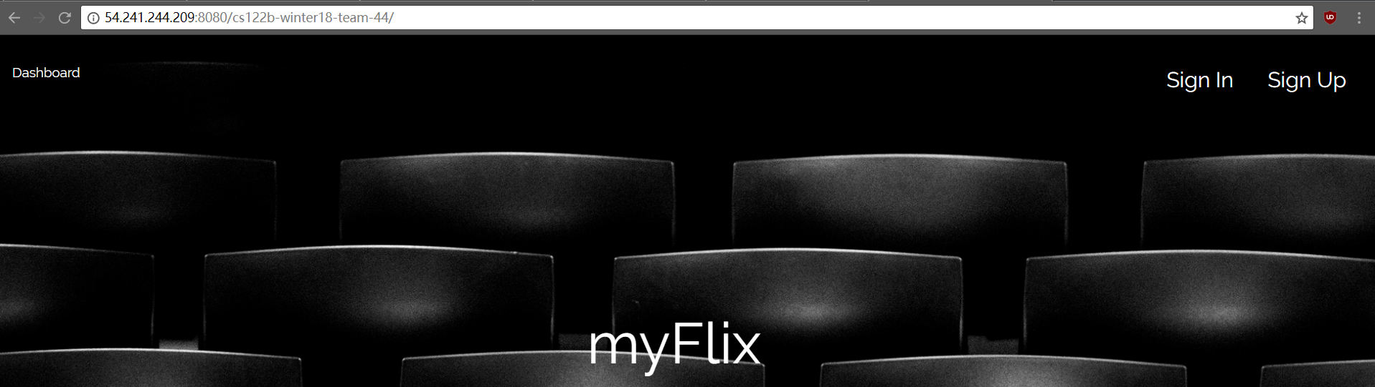

On google instance: <http://35.229.78.83/cs122b-winter18-team-44/>

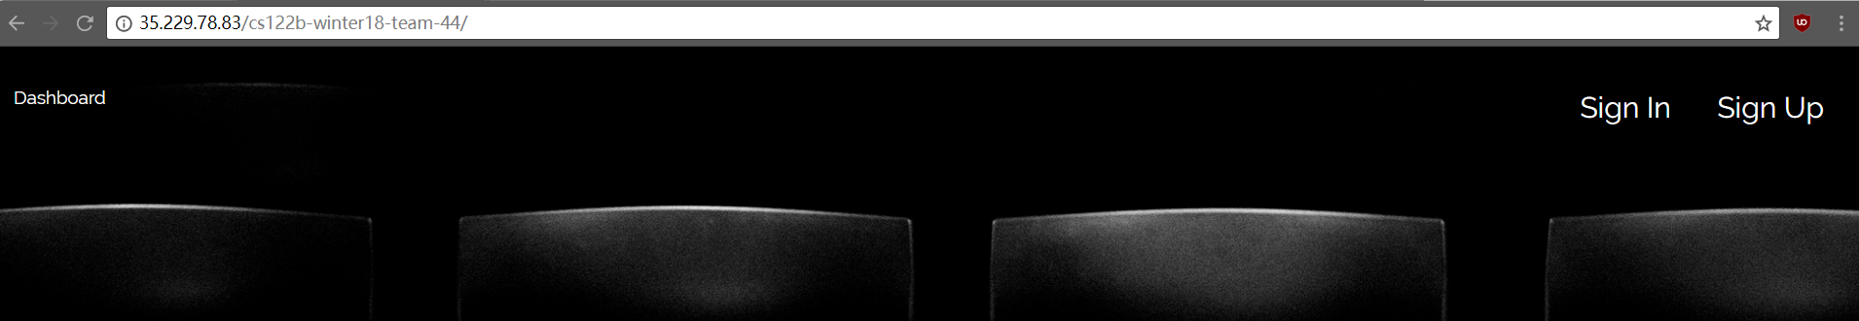

80 port for google and 8080 port for AWS has already been opened.

* **How read/write requests were routed?**

The read or write requests will be sent to either of the two servers but the write request will only be handled by master mysql server. For example, in operation.jsp, the request to insert the data is only sent to the master instance. It is located in /**WebContent**/, **line 119:**



Also, as we have defined the session part:

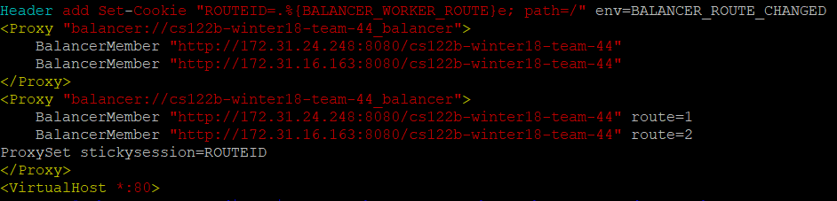

Each of the request will only be sent to one of the server when it comes to using the session.

**Task 3**

* Have you uploaded the log file to Github? Where is it located?

Yes.

https://github.com/UCI-Chenli-teaching/cs122b-winter18-team-44/tree/master/Other_file/testdata

* Have you uploaded the HTML file to Github? Where is it located?

Yes.

https://github.com/UCI-Chenli-teaching/cs122b-winter18-team-44/blob/master/WebContent/jmeter_report.html

* Have you uploaded the script to Github? Where is it located?

Yes.

https://github.com/UCI-Chenli-teaching/cs122b-winter18-team-44/blob/master/Other_file/test.py

* Have you uploaded the WAR file and README to Github? Where is it located?

Yes

https://github.com/UCI-Chenli-teaching/cs122b-winter18-team-44/blob/master/Other_file/cs122b-winter18-team-44.war